**Views**

Consider the **SELL_MANAGE** database which has the following relationship:

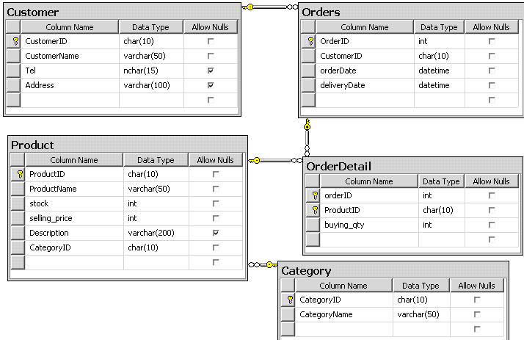

# Write the SQL statements to:

1. Create a view named cus_order_vw based on information from Customer and Orders table. The information that is to be included in th view is given below: **OrderId, CustomerId, CustomerName, OrderDate, deliveryDate.**
2. Test the view by displaying information from it. Display all the record in the view.

Display only the top 3 record in the view alphabetically sorted by Customer name.

1. Change the view such as that the CustomerID is no longer visible in the view.
2. Finally, assuming that the view is not proving useful and many managers have not

used it. Write the statements to remove the view.

1. Create view named Product_Report_vw to report that how many motorbike of each category that shop man have sold in October?
2. Create view named product_vw, display all items which selling price over

20000000. The view will need to check for domain integrity by using ‘WITH CHECK OPTION’ option.

1. Modifying product_vw view the following:
   * Inserting a product into view with price is 23000000 with the following

information:

# 'SP07', 'Nouvo', 20, 23000000, 'MADE IN JAPAN, 115 CUBIC CENTIMETRES', 'ML02'

* + Altering view with price of the product named ‘JUPITER MX’ into

20000000.

1. Display the actual text for Product_Report_vw view.